# **P2P process for Stock Material Purchase :**

In standard procurement, a customer purchases a material from a vendor and the material is delivered to the customer. Upon delivery, the ordered goods become the property of the customer. In a case of special procurement, the goods do not necessarily flow from the vendor to the customer**.**

**Procurement of Material for Stock:**

1. Create Purchase Requisition: It is used to create request by end user department for sourcing or purchasing of the material from external suppliers. This can be created manually or through automatic MRP
2. To create purchase requisition manually, use SAP Transaction code: ME51N
3. Enter data for material Code, Quantity required , due date of delivery, plant for which items are required to be purchased.
4. Material and Purchase groups will be defaulted from material masters

PR- 10014789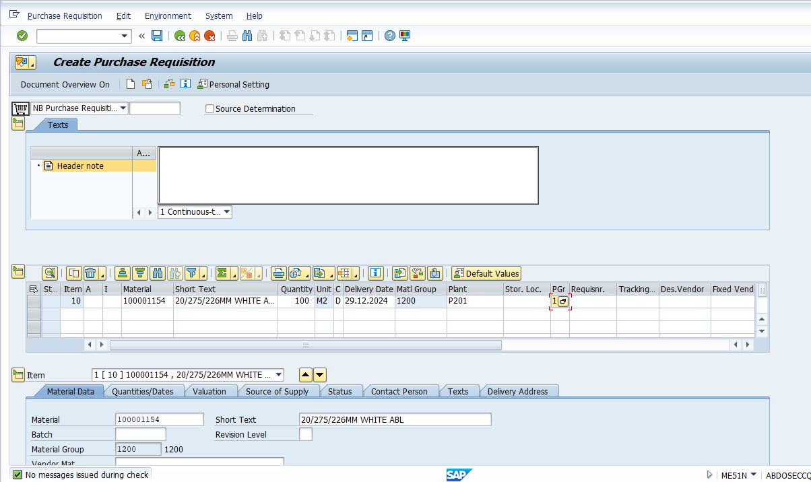

System generates above purchase requisition after saving above document.

**Create Purchase Order:**

1. Create Purchase order in reference to purchase requisition
2. System will default all the fields from purchase requisition
3. Pass the supplier code , item tax rate and price at PO line item
4. Save the purchase and system would generate a new number based on the number range assigned to PO document type in configuration

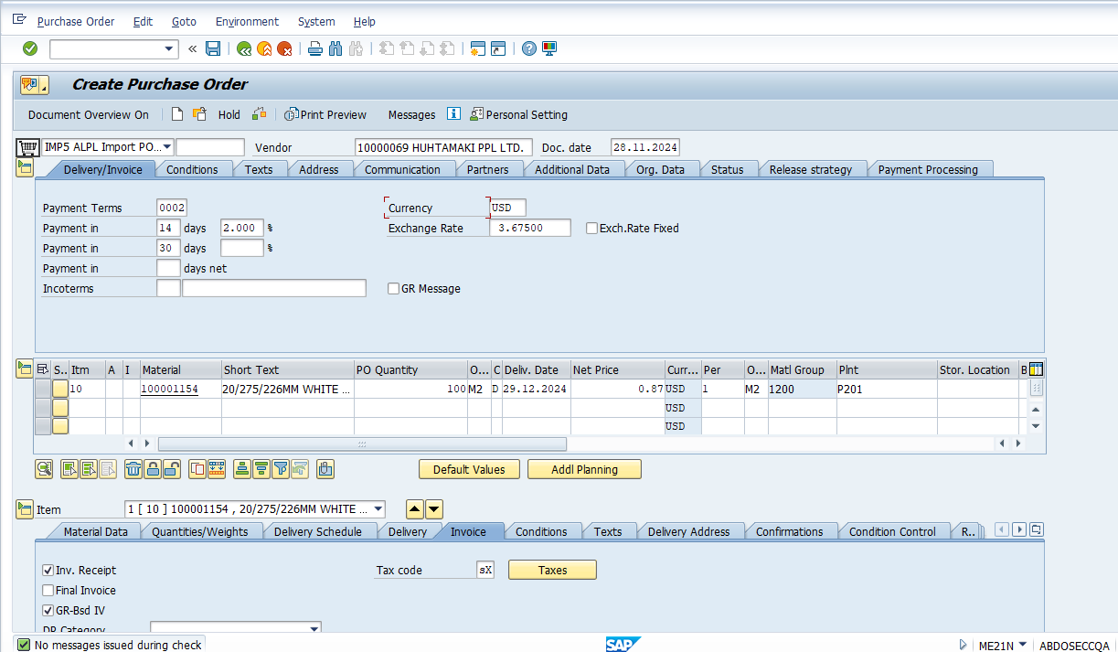

Purchase Order # PO- 5500000526 is generated.

**Release of Purchase Order**

1. System determines the release strategy based on the release strategy configuration
2. It also reads the master data maintained against class/ characteristics maintained in the system for release parameters
3. There are two ways to approve the purchase order
   1. Option1 : to approve the Purchase order through Transaction code: ME29N
   2. Option2: Setup workflow configuration, system will trigger work item in the inbox of approver
   3. Approver will use the Tcode: SBWP to approve purchase order
4. Post document approver further steps of good receipt can be executed
5. Save the approver action

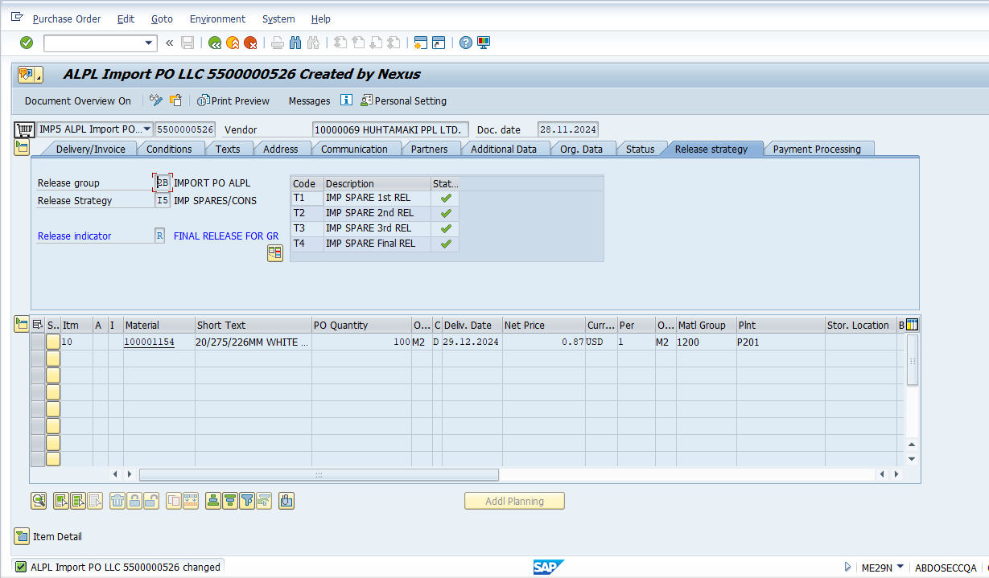

PO Released- 5500000526

**Good receipt against Purchase Order**

1. Perform GRN by SAP standard Tcode: MIGO against Purchase Order
2. System will default all the open line items with open quantity for performing good receipt ( GRN)
3. User has to authority to change the default quantity in line with actual quantity received and also to specify the storage location where stock will be physically received and placed.
4. Post saving the good receipt, system will generate a material document and accounting document show increase in GRN qty and will update financial books with increase in values.

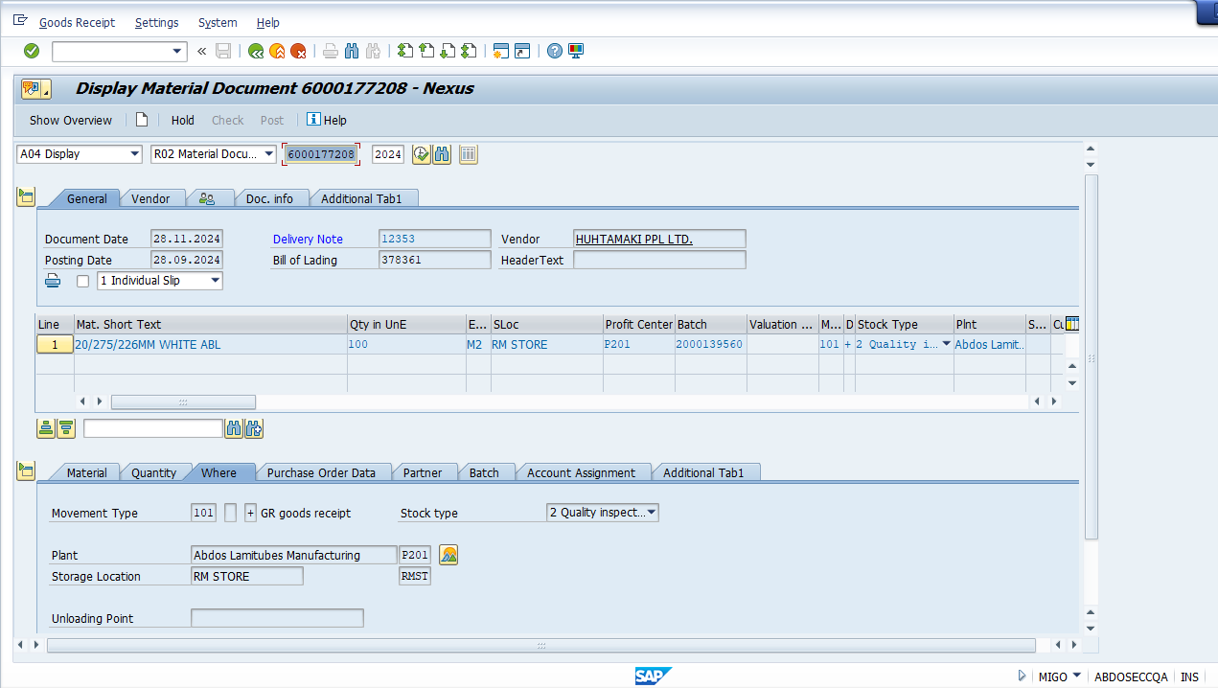

GRN document # 6000177208

**Invoice Verification against Purchase Order**

1. Perform Invoice Verification by SAP standard Tcode: MIRO against Purchase Order
2. System will default all the open line items with open quantity and value for performing good receipt vendor invoicing
3. System will default the tax code from PO line item and calculate the taxes
4. System does 3- way matching among PO, Good Receipt and Invoicing to avoid any discrepancy
5. System also defaults currency and payment terms to calculate the due date when invoices can be paid